认证编号：NO.QH2019520221001Y

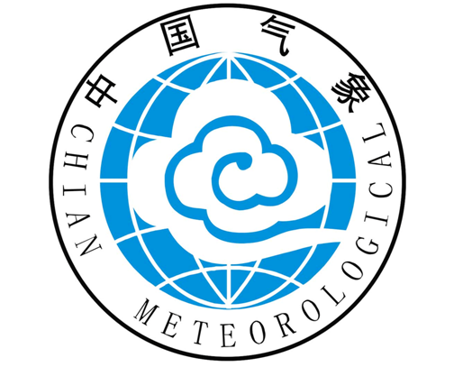

贵州省农产品气候品质认证证书
（天门红米）
农产品名称：天门红米
认证区域：贵州省水城县花嘎乡
委托单位：水城县天门村民乐种养殖专业合作社

2019年天门红米关键生育期（4～10月）天气气候特征
气象要素 | 数值
雨日数 | 116d
≥10℃积温 | 4275.4℃.d
生长期平均温度 | 22.4℃
7月平均温度 | 23.3℃
7月最高温 | 33.4℃
降水量 | 1427.6mm
相对湿度 | 80.9%
日照时数 | 729.8h

认证结论：优
证书有效期：2019年
认证单位：贵州省山地环境气候研究所

NO.QH2019520221001Y

Certificate of Climate Condition for Agricultural Products Quality
（Tianmen Red Rice）
Name of Agricultural Product: Tianmen Red Rice
Region Certified：Huaga town Shui cheng county in Guizhou Province
Authorized Agency: Professional Cooperative of Minle breeding in Tianmen Village, Shuicheng County

Weather and climate characteristics of Tianmen red rice
in 2019（ from April to October）

Meteorological Elements | Value
Rain days | 116d
10℃ Accumulating temperature | 4275.4℃.d
Growing season mean temperature | 22.4℃
July average temperature | 23.3℃
July high temperature | 33.4℃
Precipitation | 1427.6mm
Relative humidity | 80.9%
Sunshine hours | 729.8h

Certification conclusion: excellence
Term of validity: 2019
Authorized Agency: Guizhou Institute of Mountainous Environment and Climate

